**Naan Muthalvan Project:**

**InsightStream:Navigate the News Landscape**

1. **Introduction:**

Project Title : InsightStream:Navigate the News landscape

Team ID : NM2025TMID35158

Team Leader : SIVADHARSHINI.P & E-mail:sivadharshini880770@gmail.com

Team Members:

RAMYA KRISHNAN.M E-mail: senthilsenthilsurya2@gmail.com

DHARSHINI.D E-mail:dharshinidhanabal19@gmail.com

NATHIYA.T E-mail:nathiyathiyagaraj15@gmail.com

1. **Project Overview:**

**Purpose:**

To provide a user-friendly platform to view news based on date, time, district andcategory using a basic interface.

**Features:**

* Filter news by date & time, district, and category (like sports).
* Display news dynamically from a static JavaScript dataset.
* Easy-to-use input fields with real-time output.
* Supports Tamil and English interfaces.

1. **Architecture:**

**Frontend:**

* HTML5
* CSS
* JavaScript (Vanilla JS)

Interface Components:

* Date & Time selector
* District name input
* Category sections (like Sports)
* Dynamic output rendering with styled boxes

**Backend:**

* None – fully frontend-based (Static HTML + JS).
* No server or database calls are used; data is hardcoded into JavaScript for simplicity.

**Database:**

* No external database used.
* Dummy data stored in JavaScript arrays.

**Example:**

const newsData = [

{ date: "2025-09-04", time: "09:00", title: "செய்தி: புதிய கல்விக் கொள்கை அறிவிப்பு" },

{ district: "Chennai", title: "சென்னை: வானிலை திடீர் மாறுபாடு" },

{ category: "Cricket", title: "India wins ODI series..." }

];

1. **Setup Instructions:**

**Prerequisites:**

* Basic understanding of HTML, CSS, and JavaScript
* Web browser (Chrome, Firefox, Edge)
* Text editor (VS Code, Sublime Text, etc.

**Installation Steps:**

* Copy the HTML code into a .html file (e.g., index.html).
* Open the file using any modern browser.
* Interact with the input fields to view filtered news.
* (Optional) You can modify the newsData array to add more entries.

1. **Folder Structure:**

News Landscape Portal:

│

├── index.html # Main landing page (if needed)

├── assets/ # Images, icons, fonts (if applicable)

│

├── by-date-time/ # News filtered by date & time

│ └── date-time-filter.html

│

├── by-district/ # District-based news (Trichy, Chennai, etc.)

│ └── district-news.html

│

├── by-category/ # Thematic (sports, business, etc.)

│ └── sports-news.html

│

├── data/ # JSON or JS files containing news data

│ ├── newsData.js

│ └── districts.json

│

├── css/ # External CSS files (if you extract from <style>)

│ └── style.css

│

└── js/ # JavaScript for filtering logic

└── filterLogic.js

1. **Running the Application:**

**Frontend:**

* A Dynamic News Portal for Filtering by Date, Region & Category.
* Built with Simple HTML, CSS & JavaScript for Instant User Access

**Backend:**

* Robust backend architecture built with scalable APIs and efficient data pipelines to handle real-time news streams.
* Ensures secure storage, fast processing, and seamless delivery of news content to users.

**Access:**

* Provides seamless and secure access to real-time news content anytime, anywhere.
* Supports multi-platform availability with role-based permissions for users.

1. **API Documentation:**

**User:**

* Offers an intuitive and personalized interface for every user.
* Delivers tailored news feeds based on interests and behavior.

**Projects:**

* Enables creation and management of multiple news-related projects within one platform.
* Helps teams organize content, workflows, and reporting seamlessly.

**Application:**

* Delivers a unified application for seamless access to real-time news and insights.
* Combines powerful features with a simple, intuitive user experience.

1. **Authentication:**

A simple front-end based authentication mechanism can be implemented using hardcoded credentials (or localStorage/sessionStorage if extended). Currently, the provided files do not include user authentication, but it can be added as follows:

<!-- Example HTML for login -->

<input type="text" id="username" placeholder="Username">

<input type="password" id="password" placeholder="Password">

<button onclick="login()">Login</button>

function login() {

const user = document.getElementById("username").value;

const pass = document.getElementById("password").value;

if (user === "admin" && pass === "1234") {

alert("Login Successful!");

// Redirect or unlock content

} else {

alert("Invalid Credentials");

}

}

1. **User Interface (UI):**

**Modules Implemented:**

* Date & Time Based News Filter (Tamil)
* Trichy District-Based News Display (English)
* Sports News Aggregator (English)
* District News Finder (Tamil)

**UI Features:**

* Responsive layouts
* Card-style news display (.news-box)
* Color-coded feedback for no results
* Local language (Tamil) support in some modules.

1. **Testing:**

**Tested On:**

* Browsers: Chrome, Edge, Firefox
* Devices: Desktop and Mobile

**Manual Test Scenarios:**

**Test Case Expected Result Status**

Select valid date with news News cards displayed ✅ Passed

Select date with no news “No news available” message shown ✅ Passed

Enter valid district Related news shown ✅ Passed

Enter invalid/unknown district Error message in red ✅ Passed

Check sports section All categories displayed properly ✅ Passed

1. **Screenshots or Demo:**

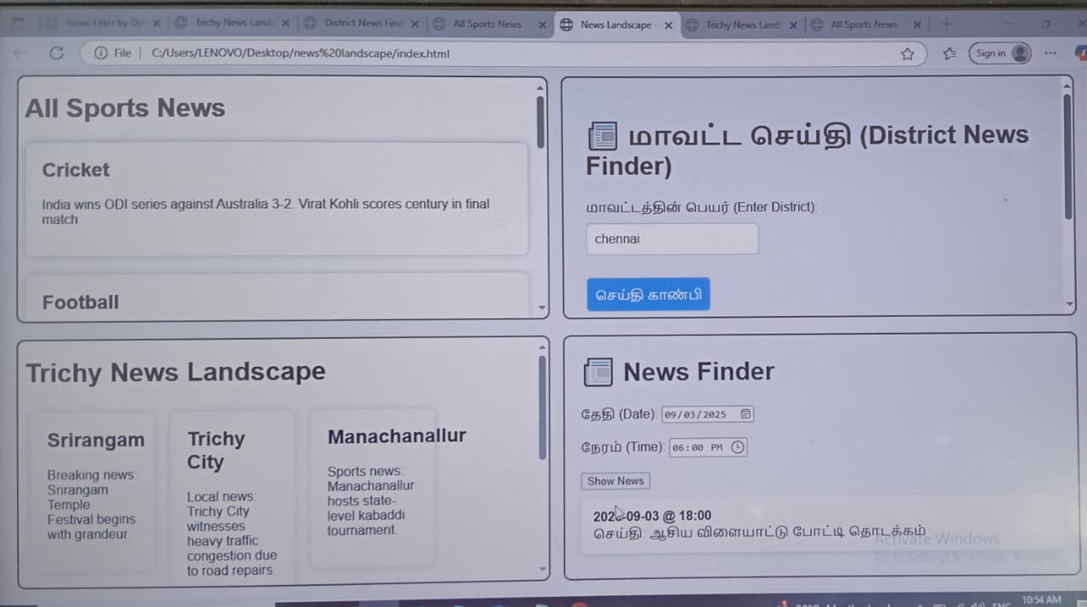

* Homepage – Title and modules
* Date-based News Filter – With result and no-result examples
* District News Module – Tamil version with Chennai input
* Sports News Section – Card-style sports news layout

1. **Known Issues:**

**Issue Impact Level Notes**

No persistent login (authentication) Medium Only dummy frontend login

No backend or dynamic DB connection High Data is hardcoded

No search suggestions for district input Low Can enhance with autocomplete

Not mobile-optimized for all layouts Medium Needs media query additions

1. **Future Enhancements:**

* 🔐 Proper authentication with backend (PHP, Node.js, Firebase)
* 🌍 Multi-language support toggle (Tamil & English switch)
* 🗃️ Dynamic news from API or JSON server
* 📱 Responsive design improvements
* 🧠 AI-based news recommendations
* 🔎 Search bar with autocomplete for districts and news
* 📅 Range-based date filter for news history.